1. Solve: 
2. Solve the equation: 
3. Solve the inequality: 
4. Solve the inequality: 
5. Evaluate the piecewise function at the given value of the independent variable.

f(*x*) = 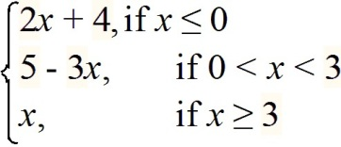  **f(4)**

1. Find the domain of the function: 
2. Find and simplify the difference quotient: f(*x*) = 2*x* + 1
3. Given , find 
4. How can the graph of  be obtained from the graph of  ?
5. Find the axis of symmetry and the range off(*x*) = 4*x*2 - 3*x* - 8
6. Determine whether the given quadratic function has a minimum value or maximum value. Then find the coordinates of the minimum or maximum point.

f(*x*) = 4*x*2 - 3*x* - 8

1. A rancher needs to enclose two adjacent rectangular corrals, one for cattle and one for sheep. If the river forms one side of the corrals and 330 yd of fencing is available. What is the largest area that can be enclosed?
2. Find a formula for the inverse. 
3. Expand the logarithmic expression as much as possible. 
4. Solve the exponential equation 
5. Solve the logarithmic equation. 
6. Solve the logarithmic equation. 
7. Find the accumulated value of an investment of $5000 at 5% compounded monthly for 8 years.
8. The population of a particular country was 23 million in 1981; in 1986, it was 30 million. The exponential growth function  describes the population of this country *t* years after 1981. Use the fact that 5 years after 1981 the population increased by 7 million to find ***k*** to three decimal places.
9. 
10.   Find 
11. Find the product, if possible. 
12. Find the values of the variables in the equation.

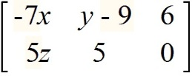 + 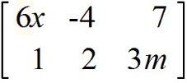 = 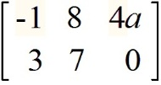

1. Find the inverse of the matrix, if possible. 
2. Evaluate the determinant. 
3. Evaluate the determinant. 
4. Orange juice, a raisin bagel, and a cup of coffee from Kelly’s Koffee Kart cost a total of $4.10. Kelly posts a notice announcing that, effective the following week, the price of orange juice will increase 50% and the price of bagels will increase 20%. After the increase the same purchase will cost a total of $5.10, and orange juice will cost twice as much as coffee. Write the system equations only (*do not solve*).
5. Solve for ***y***using Cramer's rule.

